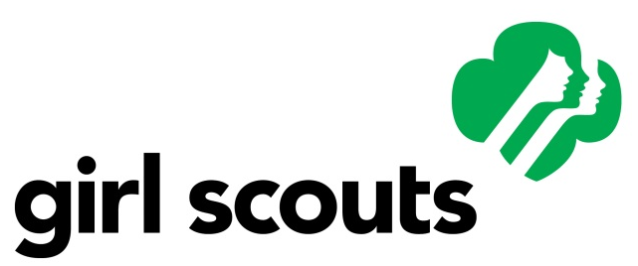

Using the Girl Scout Logo
The Girl Scouts’ name, mark and all associated insignia and slogans are the sole and exclusive property of Girl Scouts of the USA. The Girl Scout logo, or service mark, is composed of a symbol and logotype. Both parts of the service mark must be used together. The following are strict guidelines that need to be followed when using the Girl Scout logo.

- The service mark may never be redrawn, re-proportioned or modified in any way. The logotype must always be in the same proportion to the symbol. A computer-generated service mark or an artist’s rendering of the service mark is not acceptable.

- Do not shade or screen the service mark.

- The logotype accompanying the symbol may never be used as a part of the message.

- If the service mark is rendered in two colors, the symbol must be green and the logotype must be black. If it is rendered in one color, the preferred color treatment for both parts is Girl Scout green. However, reproduction of both parts in black is acceptable.

- When the service mark is reproduced, the second profile must always be the darkest. The first and third profiles must be lighter.

- Minimum airspace of at least one-third the width of the symbol should be allowed on all sides of the service mark. If space is limited, reduce the size of the service mark rather than crowd it.

- The service mark must stand alone as an element and not be crowded or lost among copy, design, graphic device or any other message. Do not place the service mark against a background of graphics, patterns or textures. The service mark cannot be used as a background design with type running over it.

If you have questions about these guidelines contact communityservice@kappadelta.org.

